Version 25 June 2015

A draft for a newsletter article

Packalen, T.1, Lier, M.1, Harper, C.2, Kleinschmit, D.3, Hervé, J.-C.4, Saint-André, L.5, Alberdi, I.6, & Dees, M.3

1Natural Resources Institute Finland (Luke), 2University College Dublin, National University of Ireland, Dublin (UCD) Ireland, 3University of Freiburg (ALU-FR) Germany, 4Institut National de l’Information Géographique et Forestière (IGN) France, 5Institut National de la Recherche Agronomique (INRA) France, 6National Institute for Agricultural and Food Research and Technology (INIA) Spain

**Distributed, integrated and harmonised forest information for bioeconomy outlooks (DIABOLO)**

**Demand and supply of information on forests for the bioeconomy in Europe**

The need for the European economy to be more innovative, productive and competitive whilst using fewer resources and reducing its environmental impact has been widely addressed (EC 2014 a). It is evident that Europe’s forest sector, as part of the European green infrastructure (EC 2014 b), can play an important role here and can contribute to tackling significant future social, ecological and economic challenges, such as unemployment, climate change and globalization (WHO 2012). Yet, these challenges will also increase the demands on forests, which besides wood and energy production, include carbon sequestration, biodiversity conservation, drinkable water provision, landscape management, soil fertility conservation, nutrient regulation and recreation. Moreover, the competition for land use between traditional agriculture, biomass production, and forestry is expected to increase in the future (EC 2014 c). The latest report on European bio-economy from the Standing Committee on Agricultural Research (SCAR) and the European Bio-economy Panel (2014) identified sustainable biomass production as main topic. They emphasised that the increasing demand for biomass will require new and smart production systems especially designed to ensure high levels of wood production while being sustainable.

These demands and competition have resulted and will result in new forest-related policies. These policies demand relevant, harmonised, comprehensive and reliable data in order to achieve decision-making in forest related policies. As a result, the recent Forest Strategy (EC 2013) called for harmonised information for mapping and assessing the state of forest ecosystems and their services.

Forest inventories and other ecosystem monitoring activities of EU Member States are reliable sources of forest-related information (Tomppo et al., 2010). Nevertheless due to the increasing demands by the forest and other related sectors there is a clear need to make data collection and analysis more efficient and harmonised, enhance interoperability, provide information for the main parameters on complete coverage maps and to provide the information up-to-date. Better knowledge on forest resources, their availability and their sustainable future supply can help to predict developments of forest ecosystem goods and services and thus can serve a broad range of stakeholders and create new opportunities for an innovative, sustainable and inclusive bioeconomy in Europe.

In addition to ground-based sampling data collected in national forest inventories, remote sensing data such as satellite images or aerial photographs provide important complementary information. Large area complete coverage information supports integration and harmonisation of national forest inventory data into an efficient European system of forest information. Moreover remote sensing data can provide the information on forest change and disturbance gathered in short time intervals that allows for continuously updated information on the state of Europe’s forests. The Copernicus services with the European Sentinel satellite system complemented by third party satellite data such as Landsat 8 have a great potential to allow for reliable forest sector information at a much higher quality level and with increased spatial and temporal resolution in the near future. Apart from its importance for the bioeconomy, such a European system of forest information will also constitute a pivotal tool for monitoring climate change effects on forest ecosystems.

**DIABOLO objectives**

As a response to the challenges between the demand and supply of forest information, the 4-year (2015-19) EU funded Horizon 2020 research project DIABOLO (Grant agreement No 633464) brings together 33 partners from 25 European countries (see Fig. 1) from leading European scientific institutions and experts in the field of policy analysis, forest inventory and forest modelling with a live linkage to European and national policy institutions and stakeholder networks.

DIABOLO aims to:

1. strengthen the methodological framework for more accurate, harmonised and timely information derived from forest inventories and monitoring systems, that can be fed into the EU information systems (SEIS, EFDAC);
2. support the development of EU policies and international processes relying on consistent forest information and
3. make innovative use of field-collected data and Earth observation and satellite positioning systems.

Figure 1: Countries involved in DIABOLO (in green). The shaded countries contribute also as WP leaders.



# **A new methodology framework from DIABOLO**

The following five major innovations can be expected from DIABOLO (Fig. 2) in five workpackages (WP):

* a more effective interface between science and policy (WP1);
* a faster route to impact by sharing methods/techniques for harmonization between the European National Forest Inventories (NFIs) on the state and changes of growing stock, biomass and carbon in European forest ecosystems (WP2);
* a wider scope of NFIs by developing new models and indicators related to biodiversity, conservation status, forest risk assessments, non-wood forest products and services (WP3);
* improved information about forest disturbances (e.g. on forest fires, storm, drought, insect outbreaks) and their impact utilising satellite remote sensing (WP4);
* and better understanding of biomass supply dynamics and trade-offs between land-uses (WP5).

Figure 2. The focus (as dotted boxes) of DIABOLO work packages in relation to multi-source and multipurpose NFIs (in light grey).

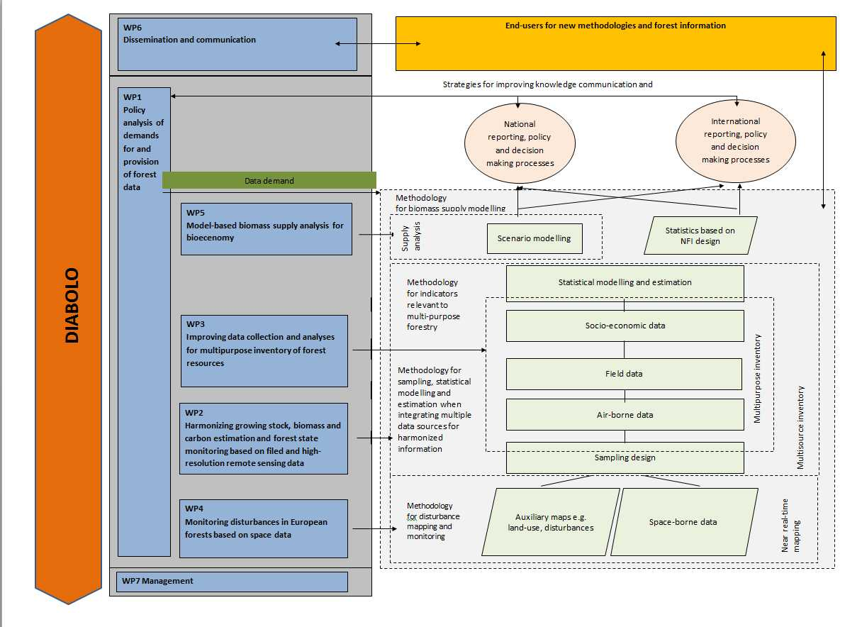

By involving 25 European NFIs DIABOLO will have an **immediate impact** on the processing of European forest information. DIABOLO will harmonise and improve European estimations of biomass supplies and non-wood forest products, on the basis of NFI plot and tree data. The impacts of the work start with more realistic bioenergy targets, securing the competitiveness of industry, and end with monitoring the paths towards achieving the targets, based on the political responses. DIABOLO foresees direct output links to EFDAC and its successor FISE for data on wood and biomass resources and their sustainable supply, and also on other forest ecosystem services, e.g. forest biodiversity and for the information on disturbances in forests. In addition, the decision support systems for the bioeconomy industries, e.g. the EU Bioeconomy Observatory (BISO), will benefit from DIABOLO, at regional and local levels, on the basis of harmonised definitions and estimations of sustainable biomass supplies. This enables the European Commission to react quickly to urgent information demands from different sectors.

**The bottom-up approach** (the direct involvement of all national data providers) applied in DIABOLO will lead to the broad acceptance of outputs on the EU member states’ scale. In addition, by integrating new Earth Observation data DIABOLO will strengthen the capacity for both assessing risks and monitoring forest disturbances on a pan-European scale and at regional levels using with high revisit cycles thus quickening the information flows. DIABOLO offers thus an effective, timely and harmonised service having a strong impact on European policies in dealing with damage from forest disturbances. This will allow both forest managers and policy makers to react effectively to prevent and solve forest damage events.

DIABOLO will also **support coherence of policy decisions** by improving the understanding of trade-offs between biomass supply and other ecosystem products and services by developing methodologies to incorporate land-use constraints and land owners’ objectives into statistically sound, harmonised, comprehensive bottom-up (from national to European) model-based biomass supply analyses.

DIABOLO’s large consortium facilitates also **knowledge transfer** from NFIs with long traditions to recently emerging ones. In addition, these emerging NFIs can take advantage of these new methods, enhancing the future quality of forest information in those countries.

**References**

European Commission 2013. A new EU Forest Strategy: for forests and the forest-based sector. http://eurlex.europa.eu/LexUriServ/LexUriServ.do?uri=COM:2013:0659:FIN:en:PDF Last accessed on 15.06.2015.

European Commission 2014 a. Horizon 2020. The EU Framework Programme for Research and Innovation http://ec.europa.eu/programmes/horizon2020/ Last accessed on 15.06.2015.

European Commission 2014 b. What is green infrastructure? http://ec.europa.eu/environment/nature/ecosystems/ Last accessed on 15.06.2015.

European Commission 2014 c. Commission Staff Working Document Impact Assessment. Accompanying the Communication. A policy framework for climate and energy in the period from 2020 up to 2030.

Tomppo E., Gschwantner T., Lawrence M., McRoberts R. E., 2010. National Forest Inventories, Pathways for Common Reporting, Springer, 612 pages.

WHO 2012. Strengthening public health services and capacity: an action plan for Europe.