Short Summary
The Horizon 2020 project DIABOLO (Distributed, integrated and harmonised forest information for bioeconomy outlooks) tackles Europe’s social, ecological and economic challenges
The increasing competition for forest resources will necessitate new forest-related policies across different sectors. These policies demand relevant, harmonised, comprehensive, reliable and up-to-date information. As a response to this challenge, the DIABOLO project brings together 33 partners from scientific institutions in 25 European countries (Figure 1), including experts in the fields of policy analysis, forest inventory and forest modelling, who have live linkages to European and national policy institutions and stakeholder networks.
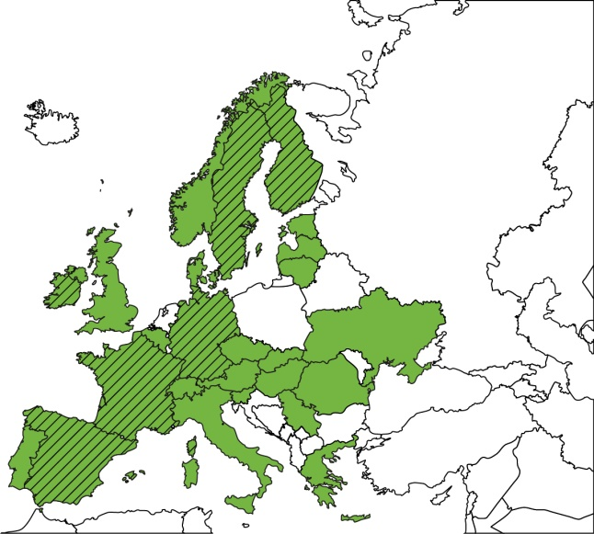
Figure 1. Countries involved in DIABOLO (in green). The shaded countries contribute also as WP Leaders

DIABOLO’s aims are to:
- strengthen the methods to produce more accurate, harmonised and timely information derived from forest inventories and monitoring systems, that can be fed into the EU information systems (SEIS, EFDAC);
- support the development of EU policies and international processes relying on consistent forest information; and
- make innovative use of field-collected data and EC space-based applications of Earth observation (see Figure 2).
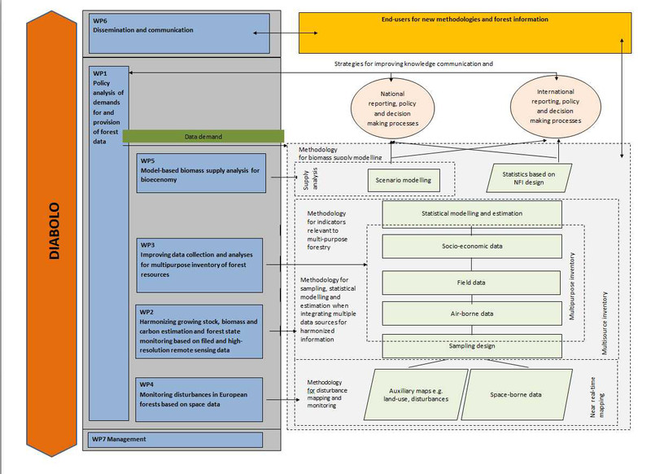
Figure 2. Interaction among the project workpackages and innovative use of field-collected data and EC space-based applications of Earth observation.
Five major innovations can be expected from DIABOLO:
- more effective interface between science and policy;
- faster impact by sharing methods/techniques for harmonisation between 25 National Forest Inventories (NFIs);
- wider scope of NFIs;
- improved timeliness in forest disturbance monitoring; and
- better understanding of biomass supply dynamics and trade-offs between land-uses.
This project has received funding from the European Union’s Horizon 2020 research and innovation programme under grant agreement No 633464. Project duration: 1.3.2015–28.2.2019. Coordinator: prof. Tuula Packalen, Natural Resources Institute Finland (Luke), tuula.packalen@luke.fi DIABOLO website: http://diabolo-project.eu/

